System Design Document

Webshop “Project56”

Hogeschool Rotterdam

Project56

Inhoud

Introduction 2

Purpose of this document 2

Project References 2

Version control 2

Target audience 3

System Overview 4

Design Goals 7

Design Constraints 8

Design Architecture 9

# Introduction

This document was created to describe and document all the design elements of the webshop that is to be created, namely “Project56”. Describing the design elements before implementing the design, will help to structure different design elements into an overall design. This should help the user to easily navigate the webshop and thus improve sales performance.

## Purpose of this document

The purpose of the system design document is to give an accurate description of the webshop “Project56”. This document is part of the modelling process that is required before a webshop can be built. Further requirements to make the webshop compatible with usual design processes include the Software Requirement System and the Use Case Specification.

## Project References

This project is based on the so called “modulewijzer” for class INFPRJ2210 (S1718-Course_Manual-OP12-INFPRJ2210.pdf). This can be found in Google Classroom.

The project and this document also reference and are referenced by the Use Case Specification and Software Requirement Specification. These documents will be delivered combined with this document.

## Version control

|  |  |  |  |  |
| --- | --- | --- | --- | --- |
| Version | Status | Date | Author | Remarks |
| 1 | Draft | 2017-09-18 | Bram Brouwer |  |
| 2 | Final | 2017-09-24 | Bram Brouwer, Jaap Jan van Hengel |  |

## Target audience

This document has been written for de Hogeschool Rotterdam. Especially for the course Analysis((NFANL22-5).

However this document is also created for the course Project 5-6. The software design process is based off this document.

# System Overview

Webshop Project56 aims to sell car parts and accessories to potential customers. To be able to do this in the most efficient way, a logical structure must be implemented. The first part of this structure is the homepage. The homepage is where the user gets the first impression of the webshop. It is very important this first impression will be good enough, otherwise the user will leave the webshop right away. Therefore it is important that the user can see at a glance that the webshop sells the category of products that he or she is looking for.

To create a successful design, a mock design must be created. This will be further referred to as a wireframe. Multiple wireframes were created for this webshop, the wireframes of the main pages will be discussed below to explain the design choices.

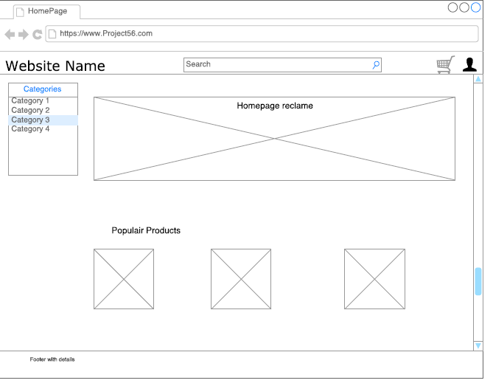

Image 1: Wireframe homepage

In the wireframe, see image 1, a part of the page is reserved for “Homepage reclame”. This section should include a text welcoming the customer to the webshop and explaining what this webshop is for. Also, some highlighted products could be shown here. Below this, we find the populair products section. This might lead the user directly to the product that a lot of users were interested in before.

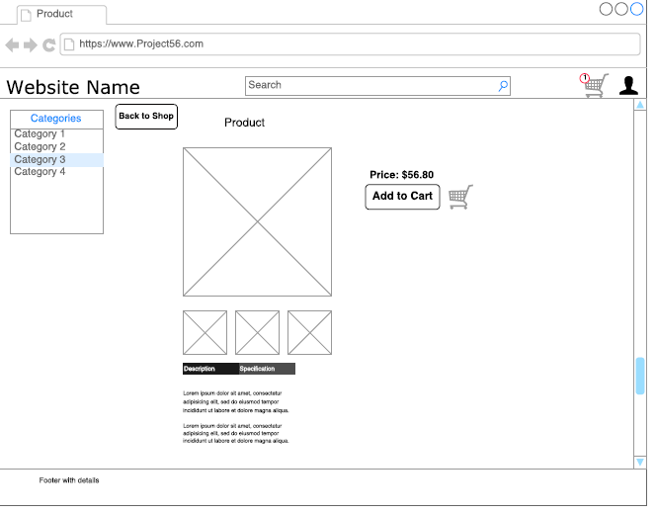

Image 2: Wireframe productpage

In the wireframe displayed in image 2, the basic frame of the page stays the same with the homepage. This will make the user feel at ease with the page, only the product information of the specific product is displayed. The menu with product categories stays in the same place on every page, so a customer can easily navigate to the next product or lookup another product.

Aside from the category menu, there is a centralized search bar at the top of the website. A user starts reading from the top, left to right. Thus, the first thing the user will see, is the page name. This gives the user information in which part of the webshop he is. The second thing the user sees, is the search bar. This invites the user to look for the product that he or she is looking for, within the webshop. The aim of this search bar is to make it as easy as possible for a user to find the products in the webshop at all times.

Furthermore, on the top right, two icons are located. This is another important location where users usually look to find settings or account information. This is where the shopping cart and the user login are located.

# Design Goals

The main goal of the design is to make the user feel at ease in this webshop. This will make the user stay on the website longer, and make the user buy more products. A couple design theories are implemented, amongst which are the ‘gestaltprinciples’.

On all pages, grouping of different groups of elements are separated by shapes and sizes. A good example of this is the popular products section on the homepage, where you can see that similar shapes and sizes of products are grouped together horizontally. According to Heinke, D., & Humphreys, G. W. (2003), this should make it easier for a user to keep the overview of the page and make it look organized.

On the product page, the “add to cart” button, is emphasized by making this relatively large. The reason for this is to tempt the user to click this button. The size of the button will likely attract the attention of the user, after which the user will be doubting to click this button or not. This button is almost a suggestion to buy the product.

Heinke, D., & Humphreys, G. W. (2003). Attention, spatial representation, and visual neglect: simulating emergent attention and spatial memory in the selective attention for identification model (SAIM). *Psychological review*, *110*(1), 29.

# Design Constraints

There are a couple design constraints that are to be absolutely avoided. The attention of the user, should go to the product and the process of buying this product. Flashing, colorful or otherwise visually distracting elements like advertisements, must be avoided. This kind of distraction will disturb the ‘flow’ of the customer, making it less likely that the process of buying a product will be successfully completed.

A design constraint from a developers kind of view would be time and budget. The design of a page can not take more than twenty percent of the total development time, otherwise we consider the extra time spent, relatively not profitable enough.

# Design Architecture

All users who will use the webshop have 2 ways of finding products, they can either browse for product or they can use the search functionality built in the webshop. This is just an example of the decision structure from a user perspective. This structure is displayed using a UML activity diagram which is show here in image 3.

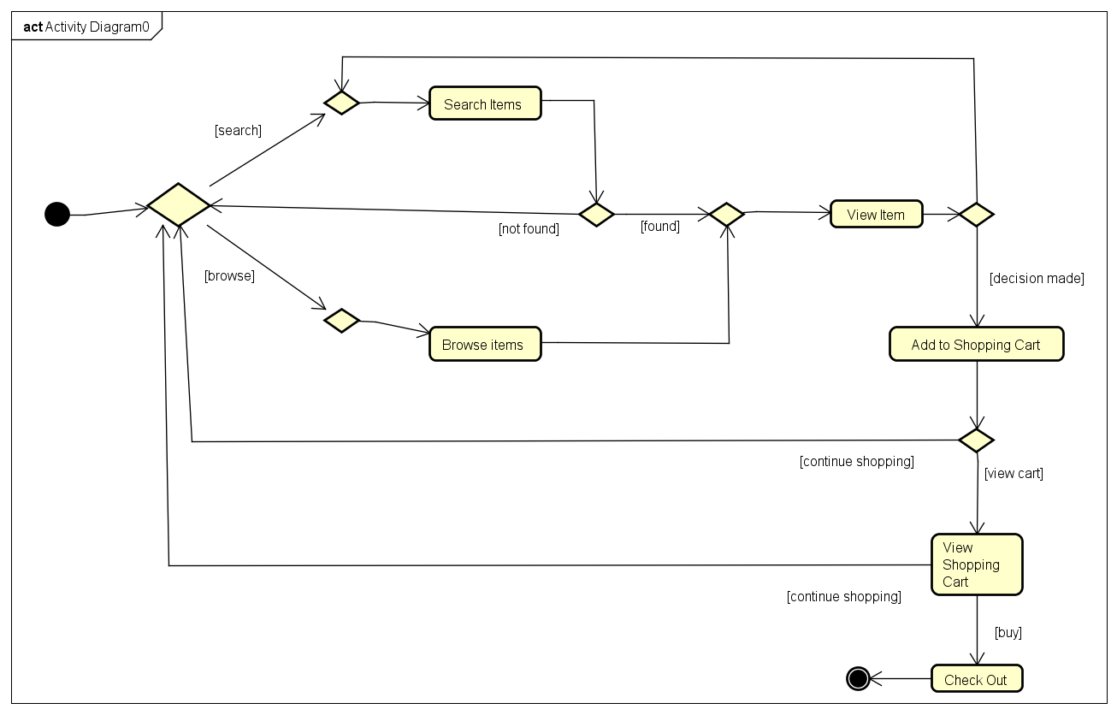

Image 3: UML Activity Diagram

An diagram like this is easy to explain and understand, both for the product owner as for the programmers. This means it is also a good reference before the development start but also during the development of a project like this.

To make it more clear which systems are involved in which steps, the steps are laid out in sequence using the UML sequence diagram. The sequence diagram is based on the actor and the steps it is able to take, ordered by a number. A step might make use of another a system which can be found on the horizontal axis.

An example would be that if a user would search for a product in the webshop, the webshop needs to send the search term to the database to see if there was a matching keyword and if so it needs to return the products which were found.

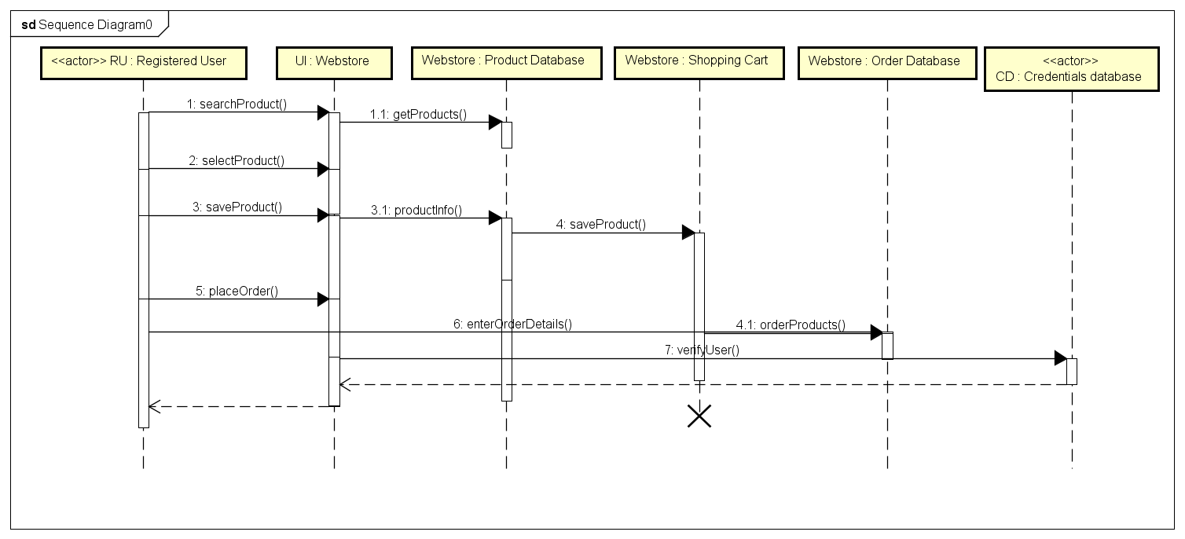

Image 4: UML Sequence Diagram

These diagrams clearly show the process of the steps a user takes on the webshop. This is important during the design phase of the project.

Another important part of the project is what the different actions and events are that can be done by person or system. For this project the Product Owner clearly stated the requirements for what a user should be able to do in the webshop. This means that it was clear from the beginning of the project what the actions were.

This is called Use Case which is clearly and widely explained in the Use Case Specification which will be delivered together with this document.

Digging a little bit deeper into the requirements and using the use case diagram, the design of the software becomes clearer.

The entities, the data structure and the web shop’s executions can be defined based on these.

This has been done using the UML Class diagram to visualize the different classes and their actions in the software. Also the data types can be filled in.

See image 5, part of the class diagram created for this specific webshop.

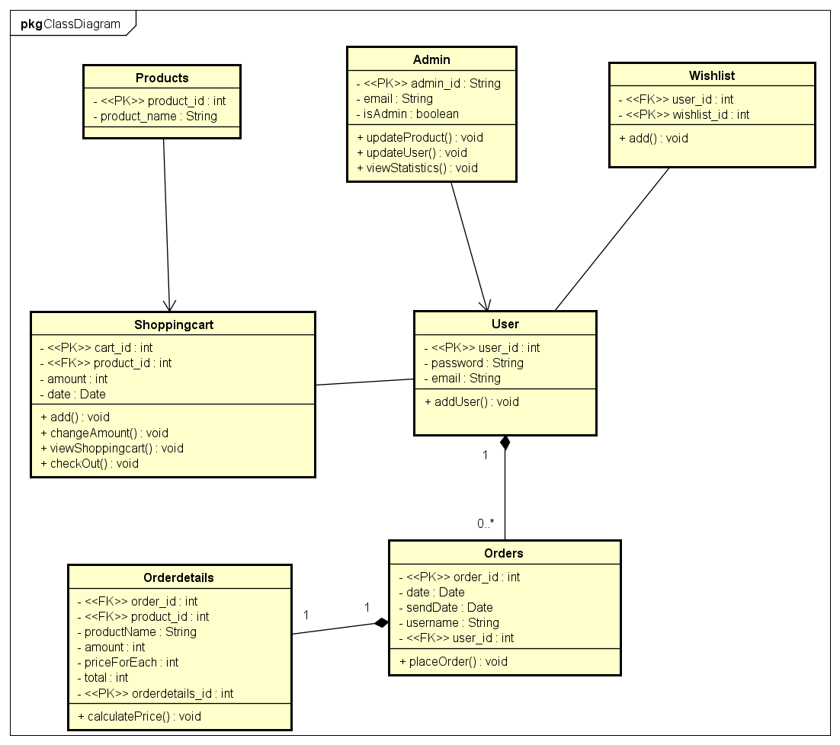

Image 5: UML Class Diagram

By now the architecture of webshop “Project56” has been modelled using diagrams and using the Software Requirement Specification and Use Case Specification.